Replacement Lab #14

Directions: View the images below and answer the following for each:
- What pathology is shown in the photo?
- What causes the pathology shown?
- What are some ways this pathology presents its self in the skeleton?
A.
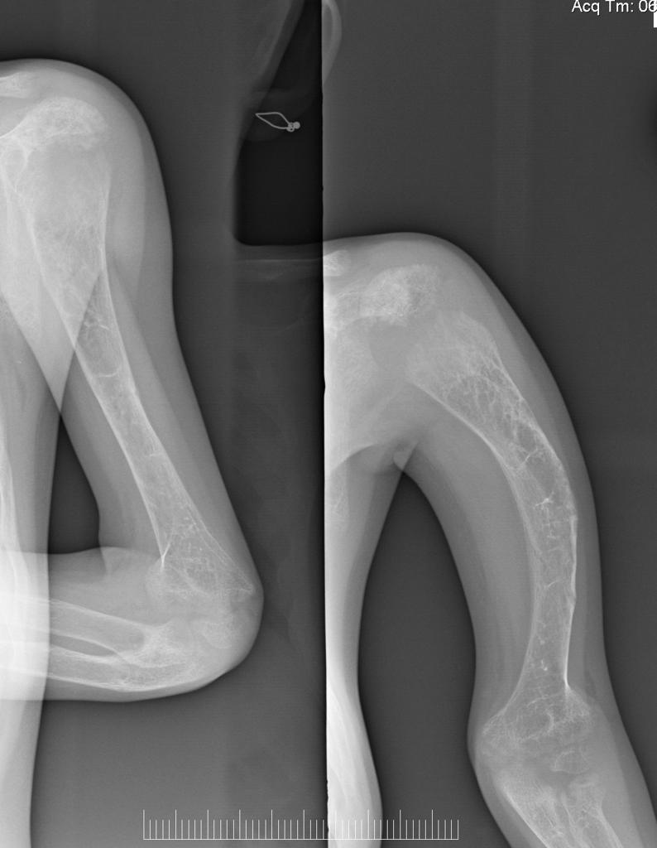
1.Humeral disease
2.humeral disease is caused by trauma, falling down or Cases of shoulder pain.
3.The Humeral disease present its self to the skeleton by bone fractures or bone cancers.

B.
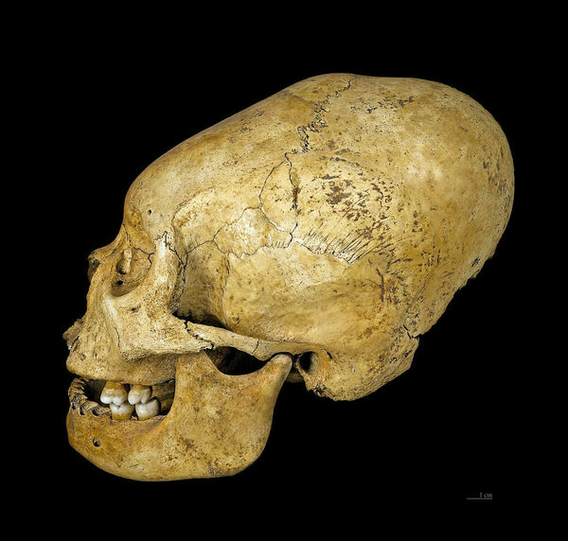
1.artificial cranial deformation
2.It is caused by changing how a child's skull by enhancing force on the skull .use of flat shapes can be used to.
3.The artificial cranial deformation affects the brain. Effect on brain disease cause hearing , impairing memory and object recognition.

C.
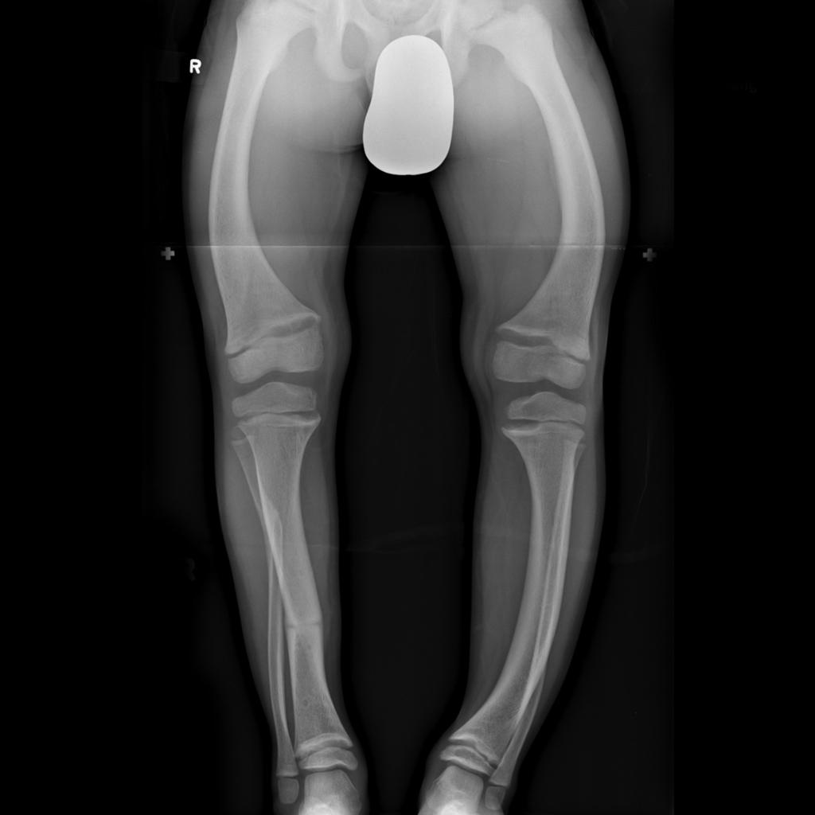
1.Rickets
2.Rickets is caused by lack of vitamin D.
3.Lack of vitamin D in ones body make it hard to sustain sufficient levels of calcium. When this occurs the body produces hormones that causes calcium and phosphate to be released from the bones.When the bones lack these minerals they start to become weak and soft hence skeletal deformities.

D. These 2 images show the same thing.
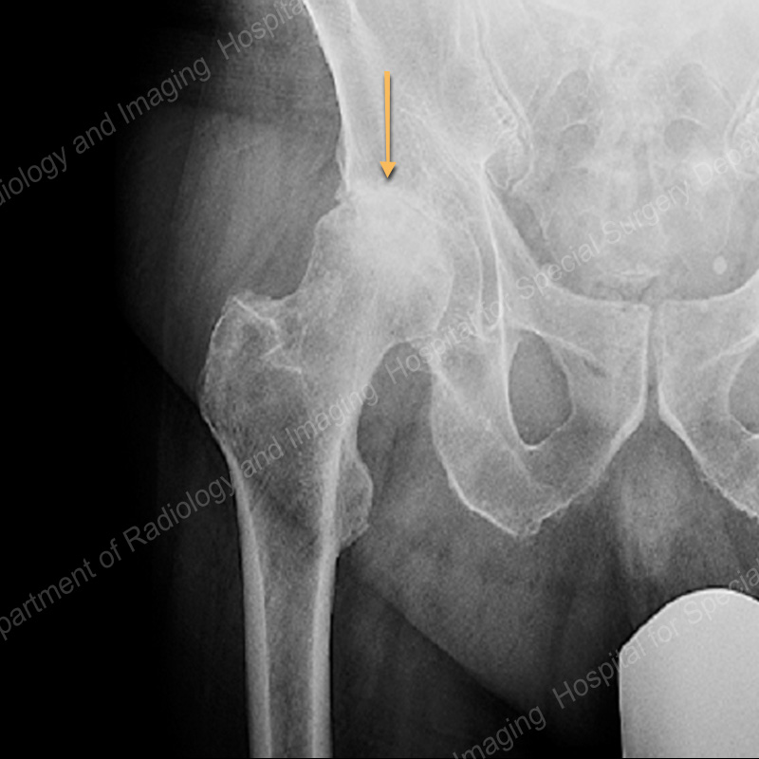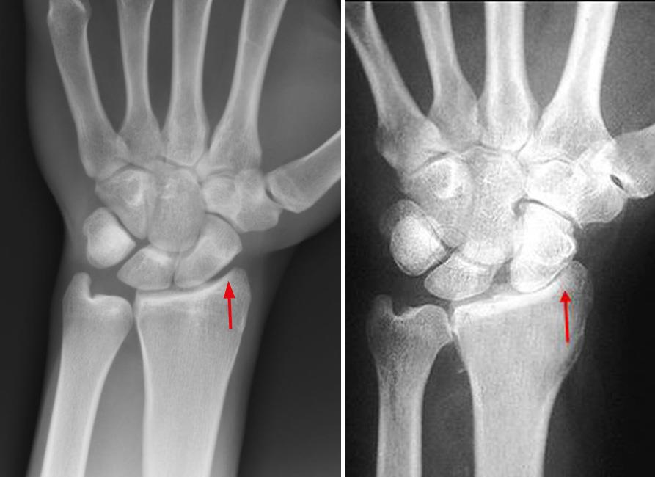
1.Bone Dysplasia
2.It is caused by a gene refered to as genetic mutation.
3.The genetic mutation halt the bones from growing in the normal way.The condition can be genetic.

